**Molecular Basis of Insulin Receptor Function Using NCBI Tools: Introduction**

[Katie M. Sandlin](mailto:kmsandlin@ua.edu)

**Insulin**

Animals are heterotrophs, and to survive, grow, and reproduce they must consume and store nutrients–carbohydrates, lipids, and proteins. During metabolism, carbohydrates and proteins are ultimately broken down into glucose, which is the primary source of energy in animals1.

Insulin is a peptide hormone that regulates the body’s energy supply by helping to maintain glucose homeostasis. Insulin controls the entry of glucose into a variety of cell types, particularly muscle cells and adipocytes, by acting as a key to open the doors of these cells to uptake glucose from the blood2 (Figure 1).

After eating carbohydrates, the bloodstream is flooded with glucose, causing the body to quickly ramp up insulin production which is then secreted into the bloodstream. The rise in insulin “unlocks” cells so they can take in the glucose flood, thus allowing glucose to be used for energy production3.

This “unlocking” happens by the binding of insulin to the cell-surface insulin receptor (INSR). This protein-protein interaction triggers the activation of signaling pathways (i.e., a chain of reactions) which promotes the usage and storage of glucose in the cells4.

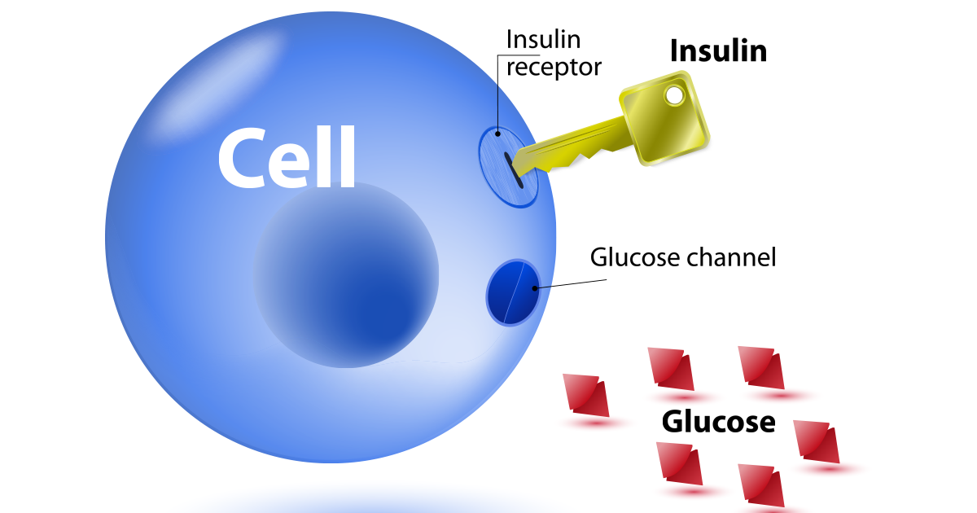

**Figure 1. Insulin serves as a gatekeeper for glucose by acting as a key to unlock the cell, which then allows glucose to enter where it can be used to produce energy. Image Source:** [**LivRite**](https://www.livritefitness.com/blog/diabetes-and-exercise/)

Insulin is a small protein that rapidly circulates in the bloodstream and binds efficiently to cell surface receptors to convey its hormonal signal5. Creating stable small proteins presents a challenge for cells because it is difficult to ensure that a small protein will adopt a stable conformation. To address this, cells initially produce a longer protein chain that then folds into the correct structure. After folding, the extra portion of the chain is removed, resulting in two smaller chains that make up the mature insulin molecule. The stability of the insulin structure is further enhanced by three disulfide bonds6.

Figure 2 shows human insulin consisting of an A-chain and a B-chain. This structure reveals key elements that stabilize the protein. Hydrophobic amino acids such as leucine and isoleucine cluster in the center, creating a hydrophobic core, while the surface is covered with charged amino acids like arginine and glutamate that interact well with the surrounding aqueous environment. Additionally, the stability of this small protein is reinforced by three disulfide bonds between cysteine residues7.

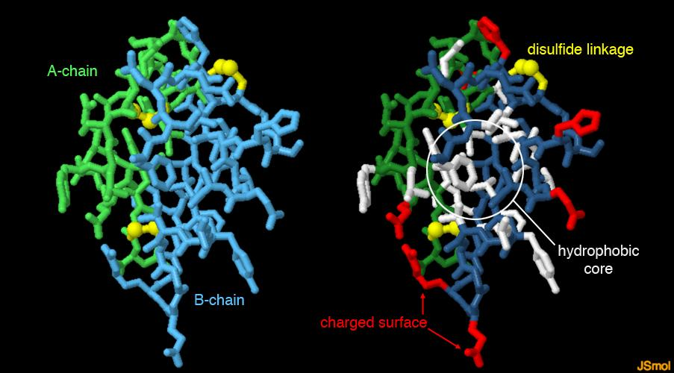

**Figure 2. Left: The protein structure of insulin with the A-chain (green), B-chain (blue), and the disulfide linkages (yellow) that connect them. Right: Charged amino acids (red) are shown on the surface of the insulin protein and hydrophobic, carbon-rich amino acids (white) are mostly buried inside the insulin protein. Image Source:** [**PDB**](https://pdb101.rcsb.org/)

While the insulin protein that binds the INSR is composed of 51 amino acids8, the process of insulin production starts with a precursor molecule called proinsulin9 (Figure 3). Similar to insulin, proinsulin contains both an A- and B-chain; however, in contrast to insulin, proinsulin also contains a 31 amino acid intermediate known as the connecting peptide or C-peptide10. Proinsulin undergoes post-translational modification to cleave the C-peptide from the A- and B-chains11.

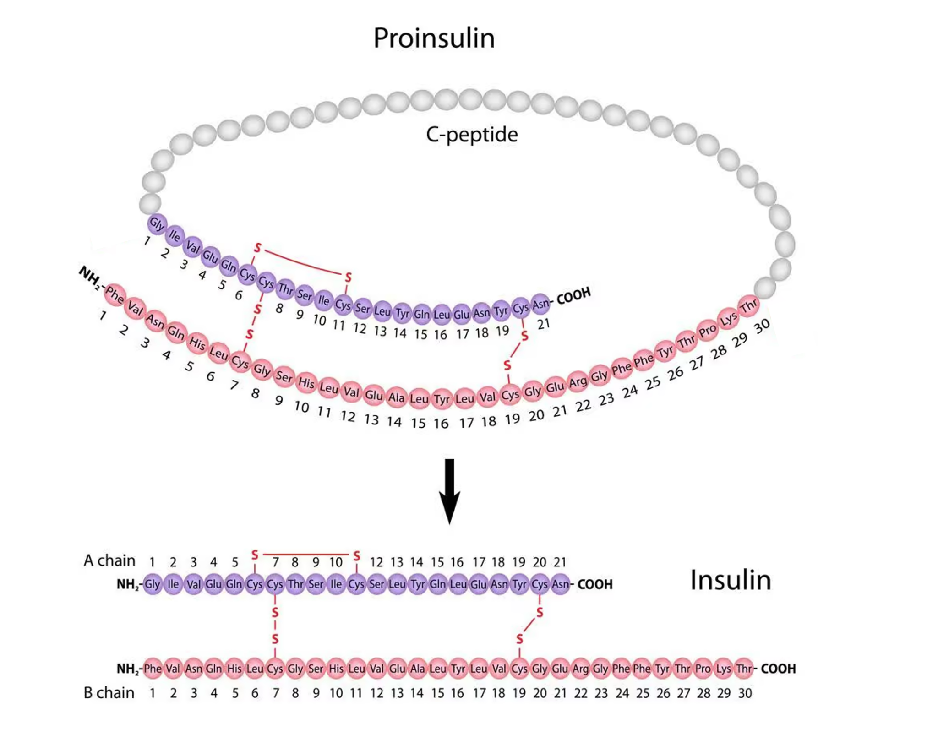

**Figure 3. Proinsulin (top) is the precursor to insulin (bottom). Both molecules contain an A- and B-chain, and proinsulin also contains a C-peptide that is cleaved post-translationally. Image Source:** [**MyEndoConsult**](https://myendoconsult.com/learn/hypoglycemia-workup/)

**Insulin Receptor**

INSR has orthologues in all metazoans12 and is a [receptor tyrosine kinase](https://www.nature.com/scitable/topicpage/rtk-14050230/) responsible for phosphorylating other proteins13. INSR is a heterotetrameric transmembrane protein composed of four subunits: two alpha and two beta. The alpha subunits are located extracellularly and are responsible for binding the insulin, while the beta subunits span the membrane and possess the tyrosine kinase activity that is activated by insulin binding14 (Figure 4).

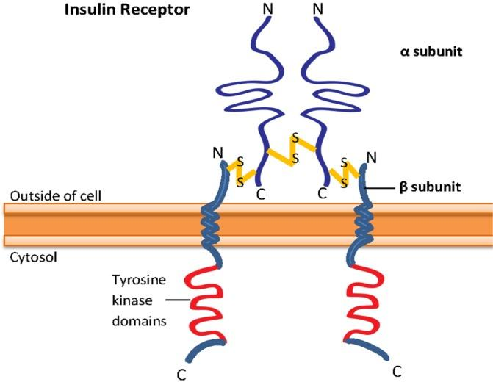

**Figure 4. The insulin receptor is a glycoprotein with a heterotetrameric structure consisting of two α-subunits that extend outside the cell and are responsible for binding insulin and two β-subunits that span the cell membrane and have tyrosine kinase activity in their intracellular domains. Image Source:** [**Mangmool et al., 2017**](https://pubmed.ncbi.nlm.nih.gov/28035081/)

INSR is encoded by a single gene15. Post-translational modifications produce a complex consisting of a single alpha-beta subunit pair. These alpha-beta dimers are connected by disulfide bonds. The alpha subunits inhibit the beta subunits allosterically, preventing them from starting a series of phosphorylation events within the cell. When insulin binds to the INSR, it triggers a conformational shift in the alpha subunits, which relieves the inhibition on the beta subunits and activates their intracellular tyrosine kinase domain. This activation leads to the transphosphorylation of the beta subunits, causing further conformational changes and an increase in kinase activity16.

When the beta subunits of the INSR are activated, they recruit docking proteins known as insulin receptor substrates (IRS). These IRS proteins are subsequently phosphorylated by the INSR. The phosphorylation of IRS proteins facilitates the assembly of insulin signaling (IS) pathway components, enabling downstream effectors to bind to and be activated by the INSR. Thus, the phosphorylation of IRS proteins initiates a cascade of signal transduction events17.

**Type 2 Diabetes**

Genes have interdependent and interacting functions within the cell18. This type of gene relationship is known as pleiotropy19. Genetic mutations in pleiotropic genes can affect not only individual gene functions but also disrupt the activities of biological pathways within cellular signaling networks20 including the IS pathway. Mutations in an IS pathway gene can cause a number of pleiotropic effects which can lead to chronic disorders such as type 2 diabetes (T2D).

T2D occurs when individuals who can still produce insulin become resistant to the hormone. As insulin resistance progresses, the body can no longer produce enough insulin to maintain normal blood glucose levels. Thus, T2D results in elevated glucose levels in the blood, known as hyperglycemia21 (Figure 5). Thinking back to our analogy of insulin as a key that unlocks cells so that glucose can enter, T2D would start with several insulin keys working poorly and then eventually running out of keys.

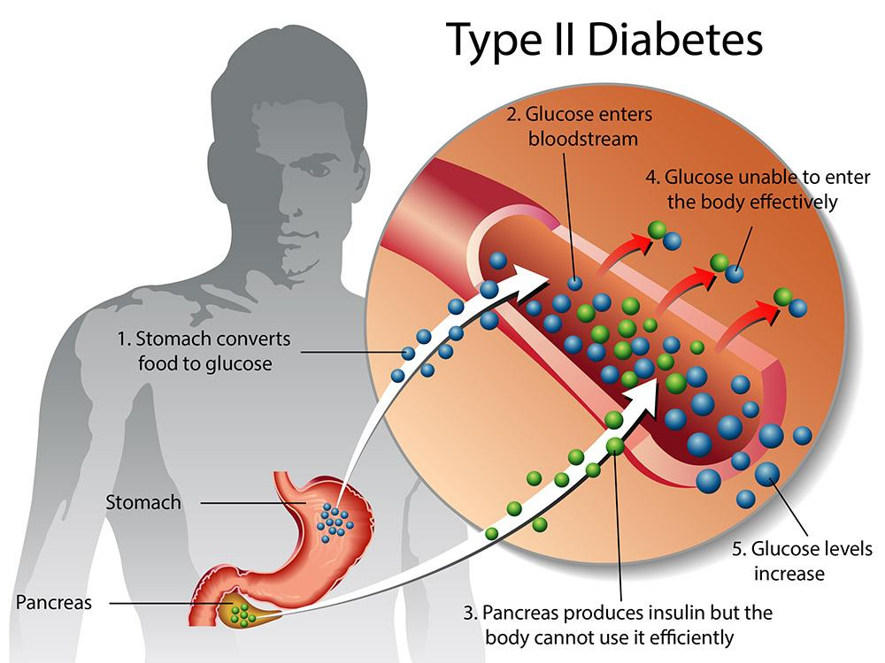

**Figure 5. Carbohydrates in food are broken down into glucose (blue) and absorbed by the stomach and small intestines. Glucose is then released into the bloodstream where it can be used immediately for energy or stored for future use. Insulin (green) is produced by the pancreas and is required for glucose utilization and storage. Type 2 diabetes occurs when the pancreas doesn’t produce enough insulin or the body’s cells fail to react to insulin, both of which lead to glucose staying in the bloodstream and blood sugar levels remaining high. Image Source:** [**Healthdirect Australia**](https://www.healthdirect.gov.au/type-2-diabetes)

With the significant rise in both the number of overweight/obese individuals and levels of physical inactivity, the incidence of T2D has surged over the past fifty years22. The Centers for Disease Control and Prevention (CDC) estimated that in 2015, T2D affected over 30 million people, or 9% of the U.S. population. If current trends continue, up to one-third of adults in the U.S. could have T2D by 205023. This growing prevalence is also seen globally, largely due to a shift toward Western lifestyles which include higher levels of physical inactivity and increased caloric intake, making T2D a worldwide pandemic rather than just a national issue24.

While environmental factors such as poor diet and lack of exercise play a role in metabolic disorders like obesity and T2D25, genetic factors also contribute to the development of these diseases. That is, T2D is a multifactorial disease (i.e., more than 1 risk factor causes T2D) with risk factors categorized into genetic and environmental factors; interactions between these factors are referred to as gene-environment (GXE) interactions. Environmental risk factors of T2D include obesity, smoking, poor diet, and physical inactivity26. Genetic risk factors can be Mendelian, for example, mutations directly affecting the insulin receptor protein function, but non-Mendelian genetic factors are more common contributors to T2D; non-Mendelian genetic factors are much more difficult to pinpoint to individual sequence variations.

**References**

1 Alberts B, Johnson A, Lewis J, et al. Molecular Biology of the Cell. 4th edition. New York: Garland Science; 2002. How Cells Obtain Energy from Food. Available from: <https://www.ncbi.nlm.nih.gov/books/NBK26882/>

2 Saltiel, A., Kahn, C. Insulin signalling and the regulation of glucose and lipid metabolism. *Nature* **414**, 799–806 (2001). <https://doi.org/10.1038/414799a>

3 Holesh JE, Aslam S, Martin A. Physiology, Carbohydrates. [Updated 2023 May 12]. In: StatPearls [Internet]. Treasure Island (FL): StatPearls Publishing; 2024 Jan-. Available from: <https://www.ncbi.nlm.nih.gov/books/NBK459280/>

4 Lizcano, J. M., & Alessi, D. R. (2002). The insulin signalling pathway. *Current biology*, *12*(7), R236-R238. <https://doi.org/10.1016/S0960-9822(02)00777-7>

5 Hua Q. (2010). Insulin: a small protein with a long journey. *Protein & cell*, *1*(6), 537–551. <https://doi.org/10.1007/s13238-010-0069-z>

6 Alberts B, Johnson A, Lewis J, et al. Molecular Biology of the Cell. 4th edition. New York: Garland Science; 2002. The Shape and Structure of Proteins. Available from: <https://www.ncbi.nlm.nih.gov/books/NBK26830/>

7 Goodsell, David. “Molecule of the Month: Insulin.” RCSB PDB. February 2001, <http://doi.org/10.2210/rcsb_pdb/mom_2001_2>

8 Weiss M, Steiner DF, Philipson LH. Insulin Biosynthesis, Secretion, Structure, and Structure-Activity Relationships. [Updated 2014 Feb 1]. In: Feingold KR, Anawalt B, Blackman MR, et al., editors. Endotext [Internet]. South Dartmouth (MA): MDText.com, Inc.; 2000-. Available from: <https://www.ncbi.nlm.nih.gov/books/NBK279029/>

9 Vergara, M. N., De la Rosa, E. J., & Canto-Soler, M. V. (2012). Focus on Molecules: Proinsulin in the eye: Precursor or pioneer?. *Experimental eye research*, *101*, 109. <https://doi.org/10.1016/j.exer.2010.11.012>

10 Akinlade, A. T., Ogbera, A. O., Fasanmade, O. A., & Olamoyegun, M. A. (2014). Serum C-peptide assay of patients with hyperglycemic emergencies at the Lagos State University Teaching Hospital (LASUTH), Ikeja. *International archives of medicine*, *7*, 50. <https://doi.org/10.1186/1755-7682-7-50>

11 Washburn, R. L., Mueller, K., Kaur, G., Moreno, T., Moustaid-Moussa, N., Ramalingam, L., & Dufour, J. M. (2021). C-Peptide as a Therapy for Type 1 Diabetes Mellitus. *Biomedicines*, *9*(3), 270. <https://doi.org/10.3390/biomedicines9030270>

12 Das, D., & Arur, S. (2017). Conserved insulin signaling in the regulation of oocyte growth, development, and maturation. *Molecular Reproduction and Development*, *84*(6), 444-459. <https://doi.org/10.1002/mrd.22806>

13 Hubbard S. R. (2013). The insulin receptor: both a prototypical and atypical receptor tyrosine kinase. *Cold Spring Harbor perspectives in biology*, *5*(3), a008946. <https://doi.org/10.1101/cshperspect.a008946>

14 Chang, L., Chiang, SH. & Saltiel, A.R. Insulin Signaling and the Regulation of Glucose Transport. *Mol Med* **10**, 65–71 (2004). <https://doi.org/10.2119/2005-00029.Saltiel>

15 Rojas Velazquez, M. N., Blanco, F., Ayala-Lugo, A., Franco, L., Jolly, V., Di Tore, D., ... & Pandey, A. V. (2024). A Novel Mutation in the INSR Gene Causes Severe Insulin Resistance and Rabson–Mendenhall Syndrome in a Paraguayan Patient. *International journal of molecular sciences*, *25*(6), 3143.

16 Yunn, NO., Kim, J., Ryu, S.H. *et al.* A stepwise activation model for the insulin receptor. *Exp Mol Med* **55**, 2147–2161 (2023). <https://doi.org/10.1038/s12276-023-01101-1>

17 Mangmool S, Denkaew T, Parichatikanond W, Kurose H. β-Adrenergic Receptor and Insulin Resistance in the Heart. *Biomol Ther (Seoul)*. 2017;25(1):44-56. <https://doi.org/10.4062%2Fbiomolther.2016.128>

18 National Research Council (US) Committee on Research Opportunities in Biology. Opportunities in Biology. Washington (DC): National Academies Press (US); 1989. 4, Genes and Cells. Available from: <https://www.ncbi.nlm.nih.gov/books/NBK217797/>

19 Lobo, I. (2008) Pleiotropy: One Gene Can Affect Multiple Traits. Nature Education 1(1):10. Available from: <https://www.nature.com/scitable/topicpage/pleiotropy-one-gene-can-affect-multiple-traits-569/>

20 Li, Y., McGrail, D. J., Latysheva, N., Yi, S., Babu, M. M., & Sahni, N. (2020). Pathway perturbations in signaling networks: Linking genotype to phenotype. *Seminars in cell & developmental biology*, *99*, 3–11. https://doi.org/10.1016/j.semcdb.2018.05.001

21 Freeman AM, Acevedo LA, Pennings N. Insulin Resistance. [Updated 2023 Aug 17]. In: StatPearls [Internet]. Treasure Island (FL): StatPearls Publishing; 2024 Jan-. Available from: https://www.ncbi.nlm.nih.gov/books/NBK507839/

22 Pappachan, J. M., Fernandez, C. J., & Ashraf, A. P. (2024). Rising tide: The global surge of type 2 diabetes in children and adolescents demands action now. *World journal of diabetes*, *15*(5), 797–809. https://doi.org/10.4239/wjd.v15.i5.797

23 “CDC Report: US Diabetes Population Tops 30 Million.” AJMC. September 30, 2017, <https://www.ajmc.com/view/medical-world-news-diabetes-data>

24 Hu F. B. (2011). Globalization of diabetes: the role of diet, lifestyle, and genes. *Diabetes care*, *34*(6), 1249–1257. https://doi.org/10.2337/dc11-0442

25 Kolb, H., & Martin, S. (2017). Environmental/lifestyle factors in the pathogenesis and prevention of type 2 diabetes. *BMC medicine*, *15*(1), 131. <https://doi.org/10.1186/s12916-017-0901-x>

26 Wesolowska-Andersen, A., Brorsson, C. A., Bizzotto, R., Mari, A., Tura, A., Koivula, R., ... & Brunak, S. (2022). Four groups of type 2 diabetes contribute to the etiological and clinical heterogeneity in newly diagnosed individuals: An IMI DIRECT study. *Cell Reports Medicine*, *3*(1). <https://doi.org/10.1016/j.xcrm.2021.100477>